Artificial intelligence (AI) is a vast field encompassing various technologies that enable machines to simulate human intelligence. AI algorithms process and analyze information from the real world, allowing them to learn, reason, and make decisions. This field has revolutionized numerous industries, from healthcare and finance to manufacturing and entertainment.

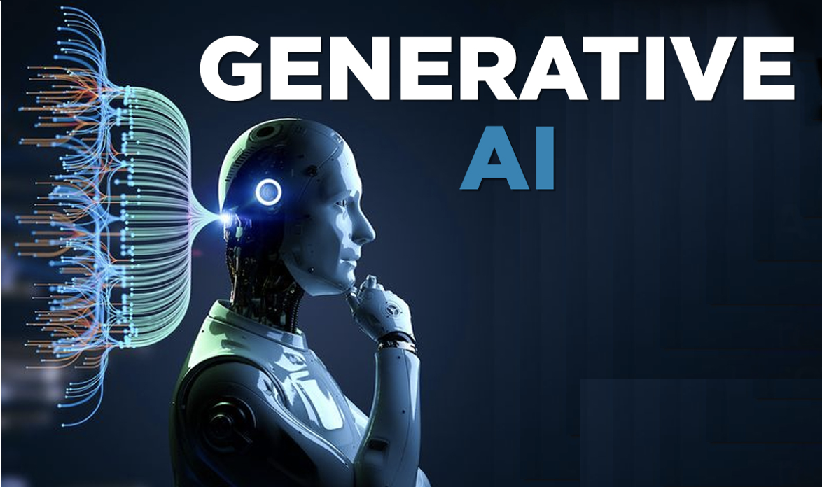

One exciting branch of AI is generative AI. This technology focuses on creating entirely new data, like images, text, or even music. Generative AI models are trained on massive datasets, enabling them to learn patterns and relationships within the data. They can then use this knowledge to produce novel content that is similar to, but distinct from, the data they were trained on. For instance, generative AI can create realistic-looking images of people who don't actually exist or compose music in the style of a famous artist.

The applications of AI are far-reaching and constantly evolving. In healthcare, AI is used to analyze medical images for early disease detection and personalize treatment plans. In finance, AI algorithms can detect fraudulent activity and predict market trends. AI chatbots are transforming customer service by providing 24/7 support and personalized recommendations. As AI continues to develop, we can expect even more innovative applications that will reshape our world.